Target SQL

Q1)  
1.1) Data type of columns in a table:  
  
select column_name, data_type  
from `target-sql-377207.Target.INFORMATION_SCHEMA.COLUMNS`  
where table_name in ('Customers','geolocation','order_items','order_reviews','orders','payments','products','sellers')  
  
  
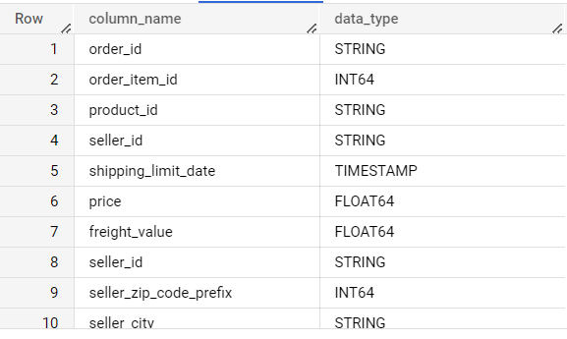

1.2) Time period for which the data is given:  
  
SELECT c.customer_id,c.customer_city,o.order_id,o.order_purchase_timestamp  
FROM `Target.orders` as o join `Target.Customers` as c on o.customer_id=c.customer_id  
where o.order_purchase_timestamp in(select min(order_purchase_timestamp) from `Target.orders`)

SELECT c.customer_id,c.customer_city,o.order_id,o.order_purchase_timestamp

FROM `Target.orders` as o join `Target.Customers` as c on o.customer_id=c.customer_id

where o.order_purchase_timestamp in(select max(order_purchase_timestamp) from `Target.orders`)  
  
  
  
  
  
  
As per the above results,we can see the first and the last order timestamp along with the cutomer id,order id,customer city.  
The data provided to us is from 4th Septemper 2016 to 17th October 2018.

1.3)Cities and States of customers ordered during the given period :-  
  
SELECT c.customer_id,c.customer_city,c.customer_state from `Target.Customers` as c join `Target.orders` as o on o.customer_id=c.customer_id  
where o.order_purchase_timestamp between '2016-09-04' and '2018-10-17'  
  
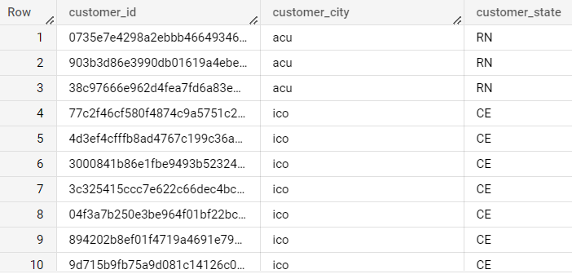  
  
This is the details of all the customers with their customer id,city,states who ordered between 4th Septemper 2016 to 17th October 2018.

Q2)  
  
2.1) Is there a growing trend on e-commerce in Brazil? How can we describe a complete scenario? Can we see some seasonality with peaks at specific months?  
  
select extract(month from order_purchase_timestamp) as month,extract(year from order_purchase_timestamp) as year,count(distinct order_id)as No_of_orders from `Target.orders`  
where order_purchase_timestamp between '2016-09-04' and '2018-10-17'  
group by 1,2 order by 2,1  
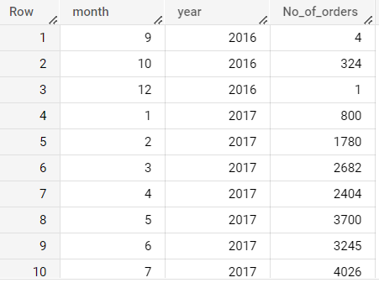

As we can see from the result there is an increasing trend in the number of orders month by month.  
In November 2017 we have recorded the highest number of orders.Also January and March in the year 2018 have number of orders which are close to the highest number of orders.   
  
select distinct QUARTER,sum(No_of_orders) over (partition by Quarter order by QUARTER)from(select  FORMAT_DATE('%b-%Y',order_purchase_timestamp ) AS mon_year,count(distinct order_id) as No_of_orders,EXTRACT(QUARTER FROM order_purchase_timestamp) as Quarter from `Target.orders`  
where order_purchase_timestamp between '2016-09-04' and '2018-10-17'  
group by 1,3  
order by 3,1)a  
  
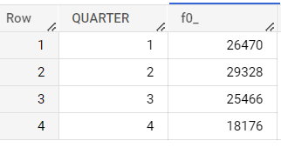

Also we can see the quarter wise sales for the overall time period.  
We can see the highest numbers of orders in the second quarter of every year accumulatively.  
  
  
  
2.2) What time do Brazilian customers tend to buy (Dawn, Morning, Afternoon or Night)?

select extract(time from order_purchase_timestamp) as timer,

case when extract(time from order_purchase_timestamp) between '00:00:00' and '05:59:59'

then 'Night (12 AM to 6 AM)'

when extract(time from order_purchase_timestamp) between '06:00:00' and '11:59:59'

then 'Morning (6 AM to 12 PM)'

when extract(time from order_purchase_timestamp) between '12:00:00' and '17:59:59'

then 'Afternoon (12 PM to 6 PM)'

else 'Evening (6 PM to 12 AM)'

end as Time_Frame

FROM `target-sql-377207.Target.orders`

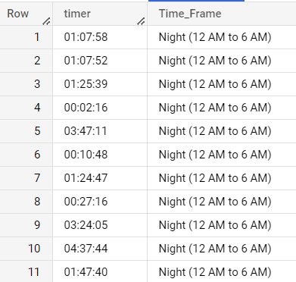

As we can clearly see from the above result,maximum orders are placed in night time i.e. from 12AM to 6PM.  
  
  
  
3.1) Get month on month orders by states

select customer_state,extract(month from order_purchase_timestamp) as Month,extract (year from order_purchase_timestamp) as Year,count(distinct order_id) as No_of_orders from `Target.Customers` c join `Target.orders`o on o.customer_id=c.customer_id where order_purchase_timestamp between '2016-09-04' and '2018-10-17'

group by 1,2,3

order by 3,2

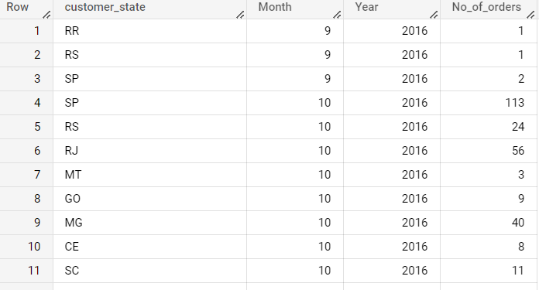

From the above result,the highest number of orders were from the State of Sau Paulo.  
  
  
3.2) Distribution of customers across the states in Brazil  
  
select count(distinct customer_id),customer_state from `Target.Customers`

group by 2

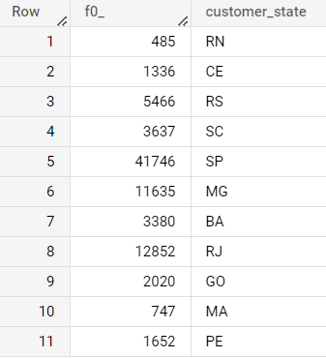  
  
Target has major customers coming in from 3 states with Sau Paulo being the highest followed by Rio de Janeiro and Minas Gerais.

4.1) Get % increase in cost of orders from 2017 to 2018 (include months between Jan to Aug only) - You can use “payment_value” column in payments table

select year,month,ifnull((Total_Value-lag(Total_Value) over (order by year,month)),0)/Total_Value * 100 as percentage_change

from(select sum(payment_value)as Total_Value,extract(month from order_purchase_timestamp) as Month,extract(year from order_purchase_timestamp) as year from `Target.payments` p join `Target.orders` o on o.order_id=p.order_id

group by year,month order by 2,1)a

where year in (2017,2018) and month in(1,2,3,4,5,6,7)

order by year,month

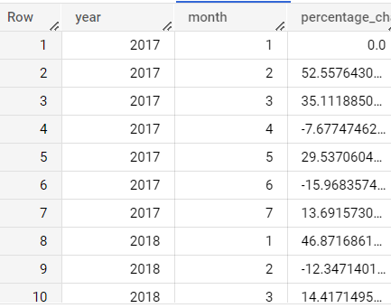  
  
  
From the above result we can observe that there is a increase in payment collected by Target from its customers in majority of the months.  
  
  
4.2) Mean & Sum of price and freight value by customer state :-  
  
select customer_state,avg(freight_value) as mean_freight_value,sum(freight_value)as sum_freight_value,sum(price)as sum_price,avg(price)as mean_price from `Target.order_items`oi join `Target.orders`o on o.order_id=oi.order_id join `Target.Customers`c on c.customer_id=o.customer_id  
group by 1  
  
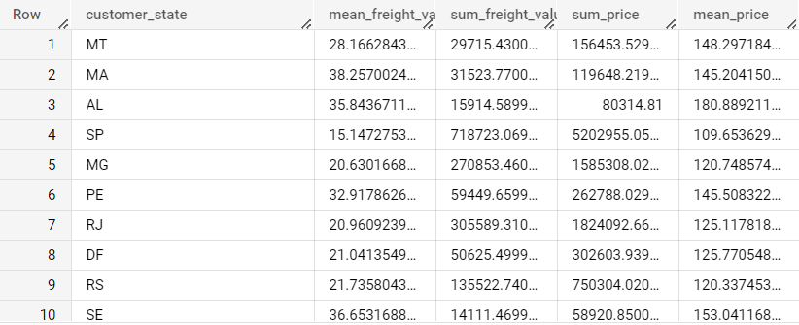

This is the mean and sum of freight value and price for each state.  
  
  
5.1) Calculate days between purchasing, delivering and estimated delivery

select order_purchase_timestamp,order_delivered_carrier_date,order_estimated_delivery_date, ifnull(Datetime_diff(order_estimated_delivery_date,order_purchase_timestamp,day),0)Approx_time,ifnull(Datetime_diff(order_delivered_carrier_date,order_purchase_timestamp,day),0)as delivery_time  from `Target.orders`  
  
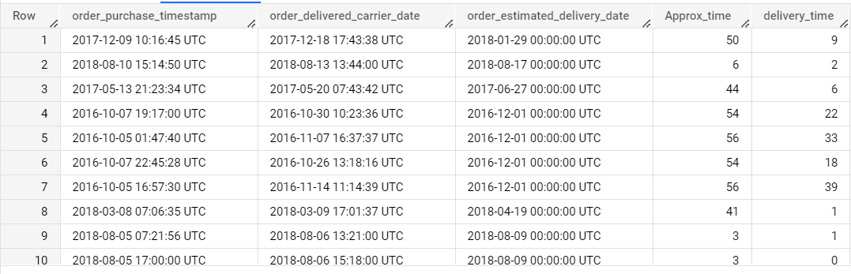

The above results tell us that the entire logistics of Target is very efficient as we can see a good amount of difference in days between the estimated and actual delivery.  
  
  
5.2) Find time_to_delivery & diff_estimated_delivery. Formula for the same given below:

* + time_to_delivery = order_purchase_timestamp-order_delivered_customer_date
  + diff_estimated_delivery = order_estimated_delivery_date-order_delivered_customer_date

select order_purchase_timestamp,order_delivered_carrier_date,order_estimated_delivery_date,datetime_diff(order_delivered_carrier_date,order_purchase_timestamp,day)as time_to_delivery,datetime_diff(order_estimated_delivery_date,order_delivered_carrier_date,day)as diff_estimated_delivery

from `Target.orders`  
  
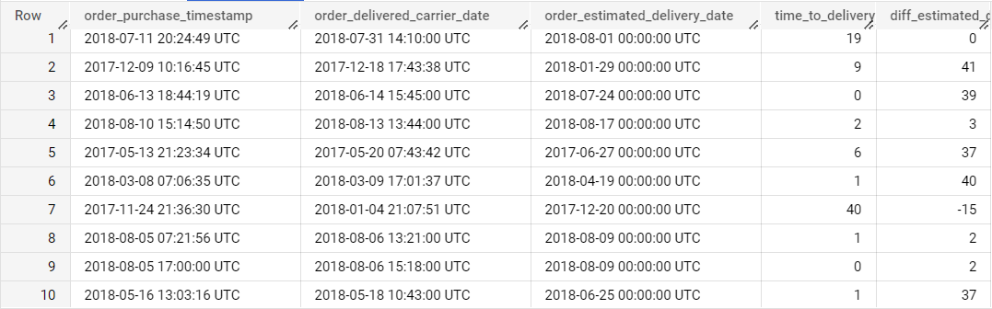

This result shows the time between order and actual delivery.It also depicts the difference in time between estimated and actual delivery which suggest the strong logistics of Target.  
  
  
5.3) Group data by state, take mean of freight_value, time_to_delivery, diff_estimated_delivery

select customer_state,round(avg(freight_value),2)as mean_freight_value,round(avg(datetime_diff(order_delivered_carrier_date,order_purchase_timestamp,day)),2)as mean_time_to_delivery,round(avg(datetime_diff(order_estimated_delivery_date,order_delivered_carrier_date,day)),2)as mean_diff_estimated_delivery

from `Target.orders` o join `Target.Customers`c on o.customer_id=c.customer_id join `Target.order_items`oi on o.order_id=oi.order_id

group by 1

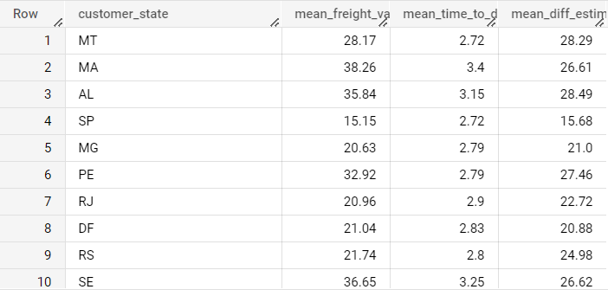

5.5) Top 5 states with highest/lowest average freight value - sort in desc/asc limit 5  
  
select customer_state,round(avg(freight_value),2)as mean_freight_value,round(avg(datetime_diff(order_delivered_carrier_date,order_purchase_timestamp,day)),2)as mean_time_to_delivery,round(avg(datetime_diff(order_estimated_delivery_date,order_delivered_carrier_date,day)),2)as mean_diff_estimated_delivery

from `Target.orders` o join `Target.Customers`c on o.customer_id=c.customer_id join `Target.order_items`oi on o.order_id=oi.order_id

group by 1

order by 2 desc

Limit 5

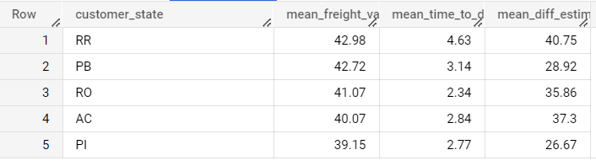

These are the top 5 states with highest mean freight value.  
  
select customer_state,round(avg(freight_value),2)as mean_freight_value,round(avg(datetime_diff(order_delivered_carrier_date,order_purchase_timestamp,day)),2)as mean_time_to_delivery,round(avg(datetime_diff(order_estimated_delivery_date,order_delivered_carrier_date,day)),2)as mean_diff_estimated_delivery

from `Target.orders` o join `Target.Customers`c on o.customer_id=c.customer_id join `Target.order_items`oi on o.order_id=oi.order_id

group by 1

order by 2

Limit 5  
  
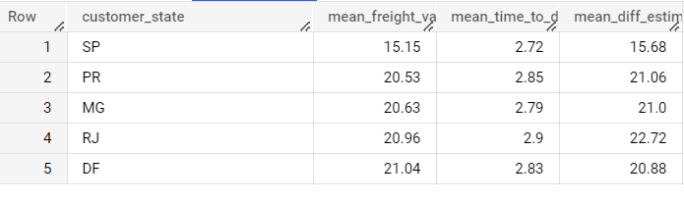

Top 5 States with lowest mean freight value.  
  
  
5.6) Top 5 states with highest/lowest average time to delivery

select customer_state,round(avg(freight_value),2)as mean_freight_value,round(avg(datetime_diff(order_delivered_carrier_date,order_purchase_timestamp,day)),2)as mean_time_to_delivery,round(avg(datetime_diff(order_estimated_delivery_date,order_delivered_carrier_date,day)),2)as mean_diff_estimated_delivery

from `Target.orders` o join `Target.Customers`c on o.customer_id=c.customer_id join `Target.order_items`oi on o.order_id=oi.order_id

group by 1

order by 3

Limit 5

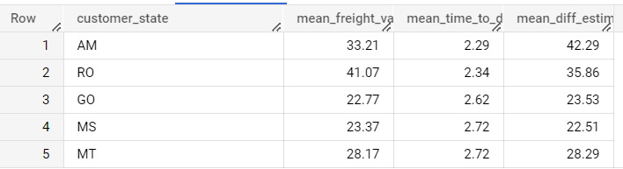

Top 5 states with lowest mean time to delivery  
  
select customer_state,round(avg(freight_value),2)as mean_freight_value,round(avg(datetime_diff(order_delivered_carrier_date,order_purchase_timestamp,day)),2)as mean_time_to_delivery,round(avg(datetime_diff(order_estimated_delivery_date,order_delivered_carrier_date,day)),2)as mean_diff_estimated_delivery

from `Target.orders` o join `Target.Customers`c on o.customer_id=c.customer_id join `Target.order_items`oi on o.order_id=oi.order_id

group by 1

order by 3 desc

Limit 5

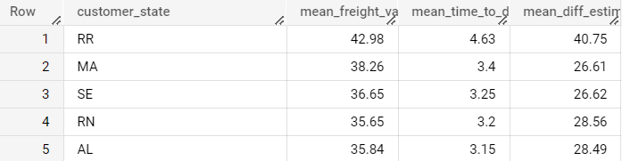

Top 5 States with highest mean time to delivery.  
  
  
5.7) Top 5 states where delivery is really fast/ not so fast compared to estimated date  
  
select customer_state,round(avg(freight_value),2)as mean_freight_value,round(avg(datetime_diff(order_delivered_carrier_date,order_purchase_timestamp,day)),2)as mean_time_to_delivery,round(avg(datetime_diff(order_estimated_delivery_date,order_delivered_carrier_date,day)),2)as mean_diff_estimated_delivery

from `Target.orders` o join `Target.Customers`c on o.customer_id=c.customer_id join `Target.order_items`oi on o.order_id=oi.order_id

group by 1

order by 4 desc

Limit 5

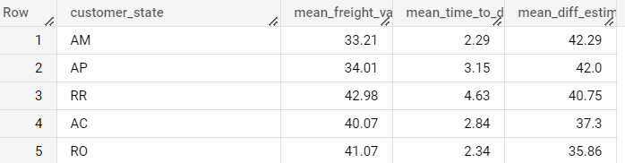  
Top 5 States with highest mean difference between estimated and actual delivery i.e. the delivery is much faster than expected.  
  
select customer_state,round(avg(freight_value),2)as mean_freight_value,round(avg(datetime_diff(order_delivered_carrier_date,order_purchase_timestamp,day)),2)as mean_time_to_delivery,round(avg(datetime_diff(order_estimated_delivery_date,order_delivered_carrier_date,day)),2)as mean_diff_estimated_delivery

from `Target.orders` o join `Target.Customers`c on o.customer_id=c.customer_id join `Target.order_items`oi on o.order_id=oi.order_id

group by 1

order by 4

Limit 5

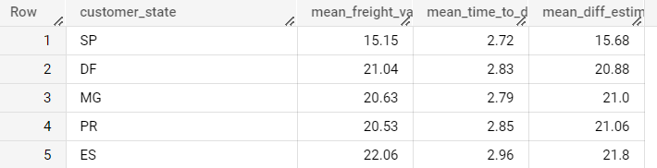

Top 5 states with lowest mean difference between estimated and original delivery i.e. the delivery is still faster than expected but not that fast as compared to the above result.  
  
  
6.1) Month over Month count of orders for different payment types

select extract(year from order_purchase_timestamp)as year,extract(month from order_purchase_timestamp)as month,count(distinct o.order_id)as no_of_orders,payment_type from `Target.payments`p join `Target.orders`o on o.order_id=p.order_id

group by 1,2,4

order by 1,2  
  
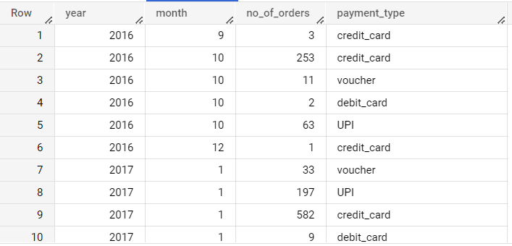

Customers use credit cards mostly.They are also utilising the vouchers and debit cards efficiently.In 1 out of 5 payments customer use UPI as well.

6.2) Count of orders based on the no. of payment installments  
  
select extract(year from order_purchase_timestamp)as year,extract(month from order_purchase_timestamp)as month,count(distinct o.order_id)as no_of_orders,payment_installments from `Target.payments`p join `Target.orders`o on o.order_id=p.order_id

group by 1,2,4

order by 1,2

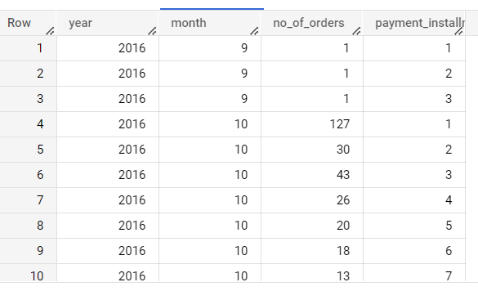  
This is the count of orders based on the number of payment installments month over month.

**Recommendations**

* There was no seasonality observed in the year 2018. Reason can be non-availability of shopping offers due to festive season, or lack of attractiveness of the offers. This is an area which can be worked upon to boost sales.
* Almost 2/3rd of the customers is coming from 3 states. Target can focus on other states to attract more customers and boost sales.
* Very less people shop at late night, this is one area where Target can focus to improve sales during this time.
* Average difference of estimated vs delivered date ranges from 8-20 days. The variance can be improved to give smoother experience to customers.
* There are states like RR, PB where freight is very high. These areas can be focused to cut operation cost related to freight
* Highest Average time to deliver a product is 28 days which is very high. This can be worked upon to cut delivery time to make customers more satisfied.
* Most of the credit card payments are having 3 or less installments, this information can be used to cross sell more products to people who use credit card.